**1Z0-819 EXAM TOPICS**

**Working with Java data types**

* Use primitives and wrapper classes, including, operators, parentheses, type promotion and casting
* Handle text using String and StringBuilder classes
* Use local variable type inference, including as lambda parameters

**Controlling Program Flow**

* Create and use loops, if/else, and switch statements

**Java Object-Oriented Approach**

* Declare and instantiate Java objects including nested class objects, and explain objects' lifecycles (including creation, dereferencing by reassignment, and garbage collection)
* Define and use fields and methods, including instance, static and overloaded methods
* Initialize objects and their members using instance and static initialiser statements and constructors
* Understand variable scopes, apply encapsulation and make objects immutable
* Create and use subclasses and superclasses, including abstract classes
* Utilize polymorphism and casting to call methods, differentiate object type versus reference type
* Create and use interfaces, identify functional interfaces, and utilize private, static, and default methods
* Create and use enumerations

**Exception Handling**

* Handle exceptions using try/catch/finally clauses, try-with-resource, and multi-catch statements
* Create and use custom exceptions

**Working with Arrays and Collections**

* Use generics, including wildcards
* Use a Java array and List, Set, Map and Deque collections, including convenience methods
* Sort collections and arrays using Comparator and Comparable interfaces

**Working with Streams and Lambda expressions**

* Implement functional interfaces using lambda expressions, including interfaces from the java.util.function package
* Use Java Streams to filter, transform and process data
* Perform decomposition and reduction, including grouping and partitioning on sequential and parallel streams

**Java Platform Module System**

* Deploy and execute modular applications, including automatic modules
* Declare, use, and expose modules, including the use of services

**Concurrency**

* Create worker threads using Runnable and Callable, and manage concurrency using an ExecutorService and java.util.concurrent API
* Develop thread-safe code, using different locking mechanisms and java.util.concurrent API

**Java I/O API**

* Read and write console and file data using I/O Streams
* Implement serialization and deserialization techniques on Java objects
* Handle file system objects using java.nio.file API

**Secure Coding in Java SE Application**

* Develop code that mitigates security threats such as denial of service, code injection, input validation and ensure data integrity
* Secure resource access including filesystems, manage policies and execute privileged code

**Database Applications with JDBC**

* Connect to and perform database SQL operations, process query results using JDBC API

**Localization**

* Implement Localization using Locale, resource bundles, and Java APIs to parse and format messages, dates, and numbers

**Annotations**

* Create, apply, and process annotations

**Format:**  Multiple Choice **Duration:** 90 Minutes

**Exam Price:** ₹18,538 **Number of Questions**: 50 **Passing Score:** 68%

**Validation:**  Exam has been validated against Java 11 **Policy:** [Cloud Recertification](https://education.oracle.com/certification-program-guidelines#2_8)

Exception handling

https://www.youtube.com/watch?v=64tQ7EhYJJk

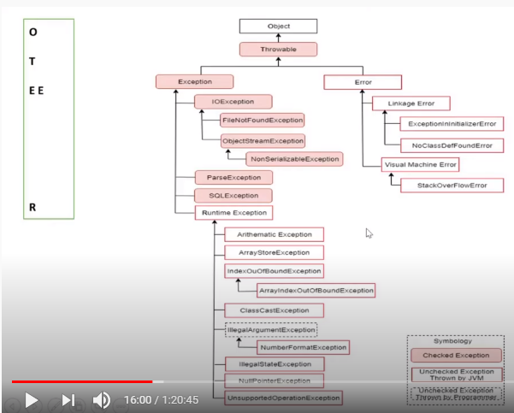

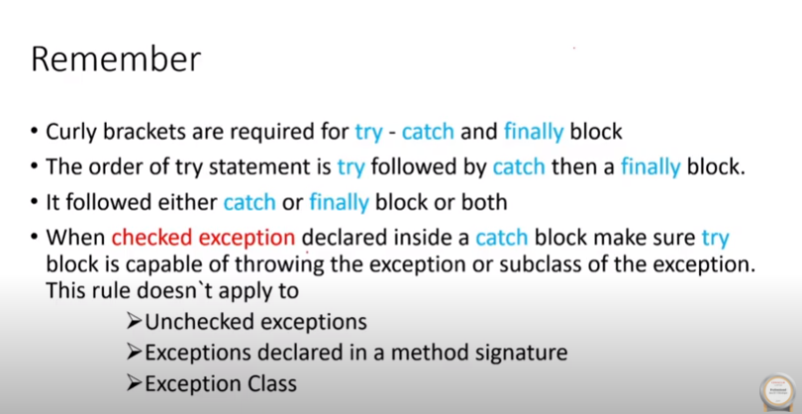

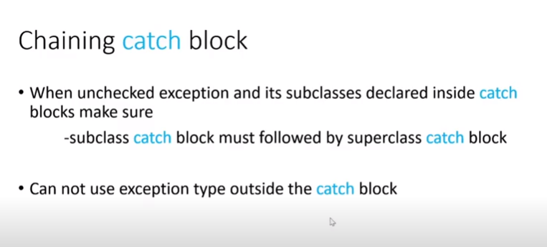

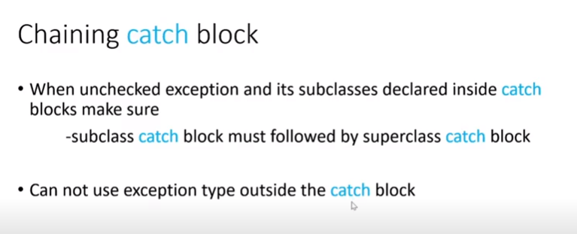

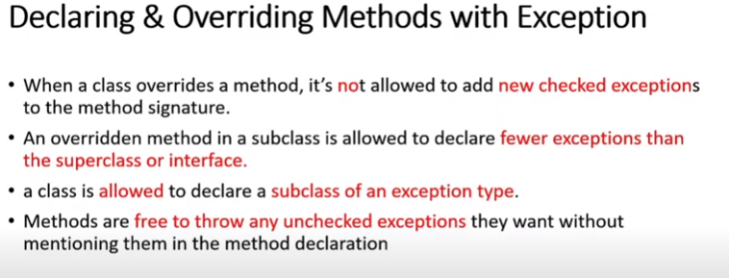

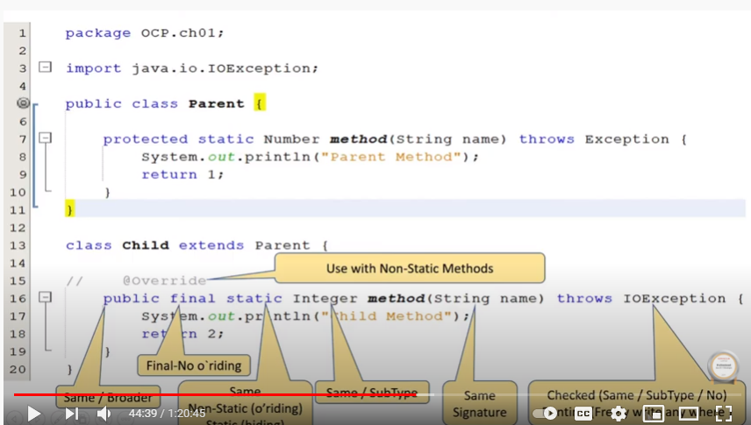

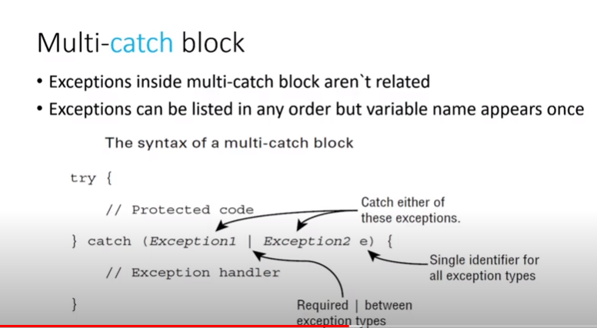

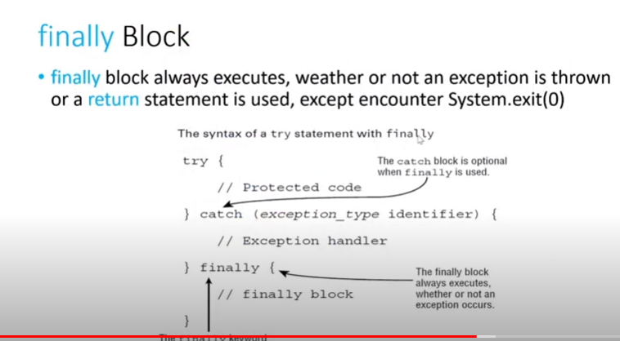

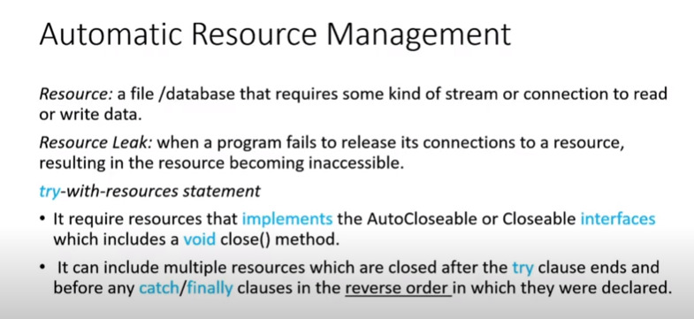

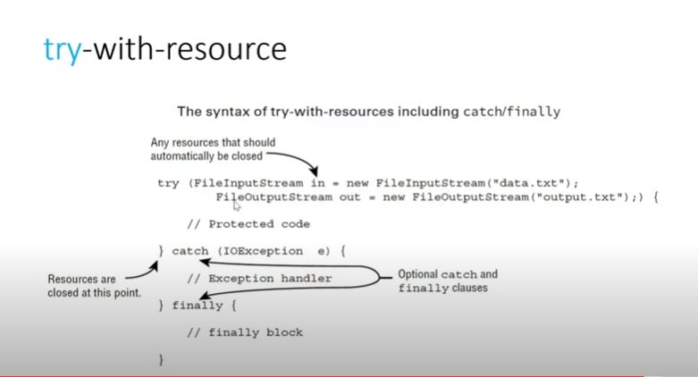

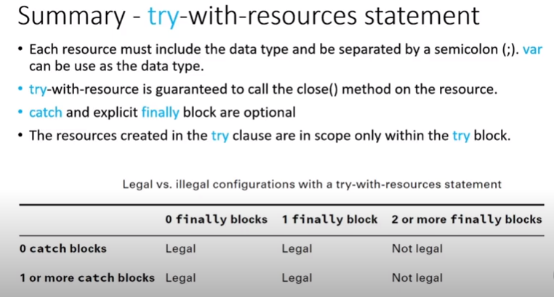

https://www.youtube.com/watch?v=XzcEOUhVtps

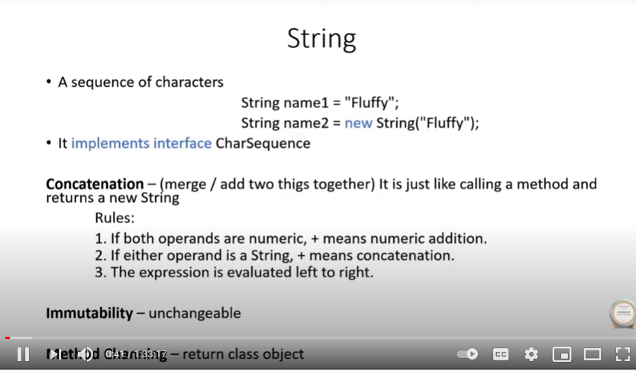

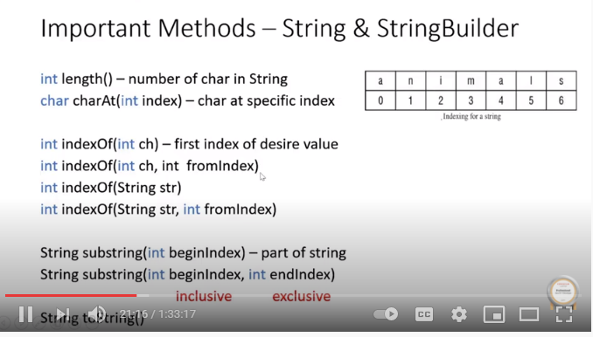

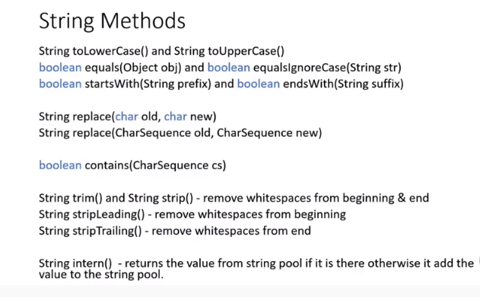

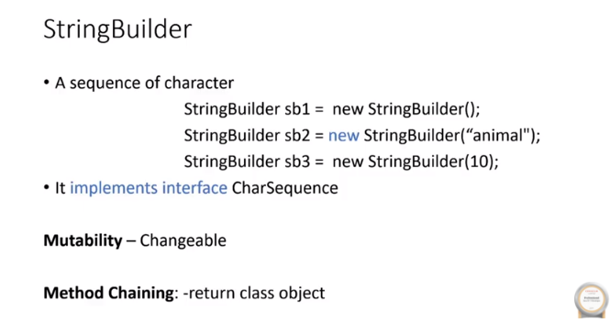

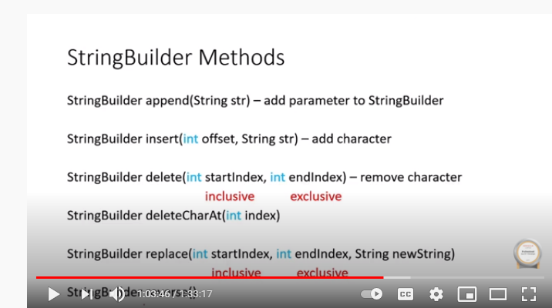

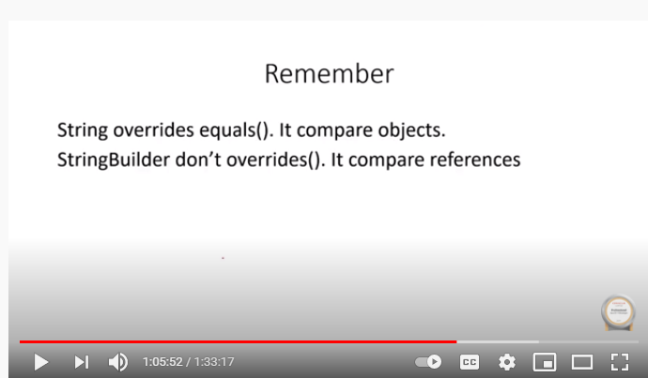

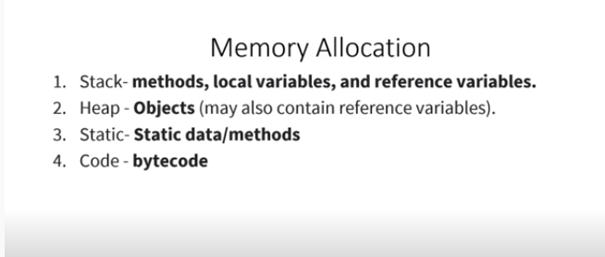

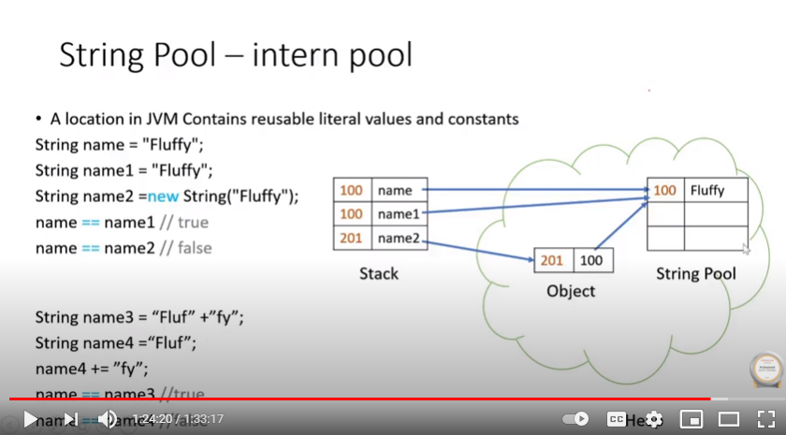

<https://www.youtube.com/watch?v=kC0xxQaqSEo>

